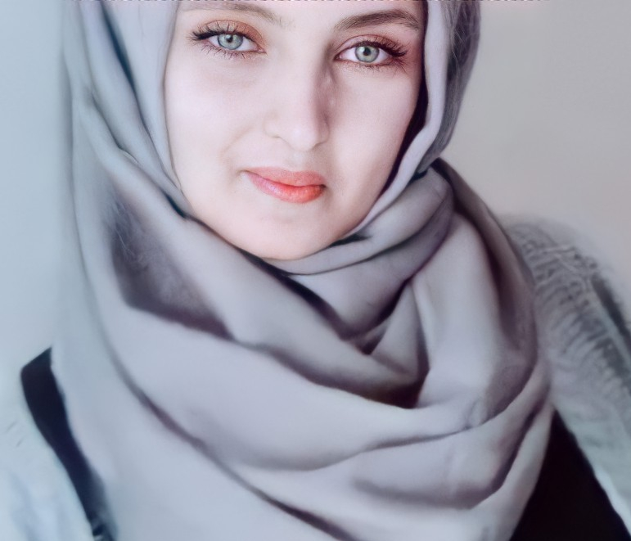

Major department : chemistry minor dep. : environmental science

CGPA : 2.92 out of 4

PHP & laravel

**Bachelor of Science, Alex. Univ.**

**Al Qabbary Hospital**

**Khalil pharmacy**

**2020**

**Learning**

1. Front end track
2. Back end track

**(Certified certificates from New Horizons Centers)**

1. Python

**(Certified certificate from free code camp)**

1. English ( conversation advanced level)
2. ICDL and MOS

**(Certified certificates from American language institute)**

1. C100 course

**(Certified certificate from Alexandria University)**

**COURSES**

**EDUCATION**

**EXPERIENCE**

Responsible for dispensing drugs prescribed by physicians and provide information to patients about medications and their use and advise them on the selection, dosage, interactions, and side effects of medications

Specialized in preparing chemotherapy on clinic pharmacy department on oncology department for cancer patients

**2020**

**2021**

**Training**

1. Egyptian European pharmaceutical industry company ( including IT training course)
2. Alexandria Electricity Distribution Company ( including IT training course)

Technical skills

[Heidyhesham3@gmail.com](mailto:Heidyhesham3@gmail.com)

Android

My SQL

React & Java Script

Bootstrap & ES6

Python

HTML5 & DNS

CSS & CSS3

Node. Js

01206386066

Elserafy st Khaled Ibn Al Walid, Sidi Beshr Bahri

Innovative optimized solution seeker. Excited to be at the deployment phase of my new career as a web developer. I am ambitious, adventurous, assiduous, animated, and an alliteration advocate.

**SKILLS**

**CONTACT**

**ABOUT ME**

**Full stack Developer**

**Hadeer Hesham**